**Topics: Descriptive Statistics and Probability**

1. Look at the data given below. Plot the data, find the outliers and find out $μ, σ, σ^{2}$

|  |  |
| --- | --- |
| **Name of company** | **Measure X** |
| Allied Signal | 24.23% |
| Bankers Trust | 25.53% |
| General Mills | 25.41% |
| ITT Industries | 24.14% |
| J.P.Morgan & Co. | 29.62% |
| Lehman Brothers | 28.25% |
| Marriott | 25.81% |
| MCI | 24.39% |
| Merrill Lynch | 40.26% |
| Microsoft | 32.95% |
| Morgan Stanley | 91.36% |
| Sun Microsystems | 25.99% |
| Travelers | 39.42% |
| US Airways | 26.71% |
| Warner-Lambert | 35.00% |

Ans: For the given data the outlier is 90.

Mean = 33.271

Standard deviation =16.945

Variance = 287.14

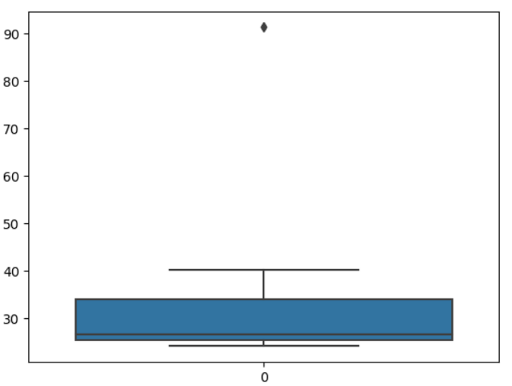



Answer the following three questions based on the box-plot above.

1. What is inter-quartile range of this dataset? (please approximate the numbers) In one line, explain what this value implies.

Ans: Approximately (first Quartile Range) Q1 = 5,Q3 = 12,Median (Second Quartile Range) = 7

IQR = Q3 - Q1

= 12 - 5

= 7

1. What can we say about the skewness of this dataset?

Ans: The skewness of the data is Right skewed.

1. If it was found that the data point with the value 25 is actually 2.5, how would the new box-plot be affected?

Ans: In that case there would be no outlier in the above boxplot because of the outlier the data had positive skewness it will reduce and the data will have normal distribution.

-

Answer the following three questions based on the histogram above.

1. Where would the mode of this data set lie?

Ans: The mode of this data set would lie approximately between 4 to 8.

1. Comment on the skewness of the data set.

Ans: The skewness of the data is positively skewed.

1. Suppose that the above histogram and the box-plot in question 2 are plotted for the same data set. Explain how these graphs complement each other in providing information about any data set.

Ans: They both are positively skewed and both have outliers.The median can be easily visualized in the box plot where as in histogram mode is more visible.

1. AT&T was running commercials in 1990 aimed at luring back customers who had switched to one of the other long-distance phone service providers. One such commercial shows a businessman trying to reach Phoenix and mistakenly getting Fiji, where a half-naked native on a beach responds incomprehensibly in Polynesian. When asked about this advertisement, AT&T admitted that the portrayed incident did not actually take place but added that this was an enactment of something that “could happen.” Suppose that one in 200 long-distance telephone calls is misdirected. What is the probability that at least one in five attempted telephone calls reaches the wrong number? (Assume independence of attempts.)

Ans: The probability that at least one in five attempted telephone calls reaches the wrong numbers is approximately 0.9950% which is 1%.

1. Returns on a certain business venture, to the nearest $1,000, are known to follow the following probability distribution

|  |  |
| --- | --- |
| x | P(x) |
| -2,000 | 0.1 |
| -1,000 | 0.1 |
| 0 | 0.2 |
| 1000 | 0.2 |
| 2000 | 0.3 |
| 3000 | 0.1 |

1. What is the most likely monetary outcome of the business venture?

Ans: The most likely monetary outcome of the business venture is 2000$ as the probability is 0.3 which is maximum as compared to others.

1. Is the venture likely to be successful? Explain

Ans: Yes the probability that the venture will make more than 0 or a profit is

P(x>0)+p(x>1000)+p(x>2000)+p(x=3) = 0.2+0.2+0.3+0.1 = 0.8

This states that there is a good 80% chances for this venture to be successful.

1. What is the long-term average earning of business ventures of this kind? Explain

Ans: The long-term average is the Expected value = SUM(X * P(X))

Expected value = (-2000*0.1)+(-1000*0.1)+(0)+(1000*0.2)+(2000*0.3)+(3000*0.1)

= -200 -100 +0+200+600+300

= 800

Therefore the long-term average earnings of business ventures of this kind is $800.

1. What is the good measure of the risk involved in a venture of this kind? Compute this measure.

Ans: The good measure of the risk involved in a venture of this kind depends on the variability in the distribution.

Higher Variance means more chances of risk,

Var(X) = E(X^2) - (E(X))^2

= 2800000 - 800^2

= 2160000